Lost or damaged materials: If any library items are lost, the replacement cost plus a processing fee of $5 may be charged. Charges for damaged materials will be based on the extent of the damage. If the item must be replaced, a processing charge may also be assessed.

Bookdrop: Videos and audio books are easily damaged if put into the bookdrop; breakage or damage can occur by falling books. Books should be returned in the bookdrop for PRINTED MATERIALS ONLY in front of the building. The borrower will be liable for non-print items damaged by the bookdrop. Please return all non-print materials to the service desk inside the library, or in the Video Return Box by the front door.

General Policies

Responsibility for the reading materials selected by children rests with their parents or legal guardians.

The use of the library or its services may be denied for due cause, which may include failure to return books or pay penalties, destruction of library property, the disturbance of other patrons, or any objectionable conduct as may be defined by the Library Board of Trustees.

THIS IS YOUR LIBRARY.

Your questions and suggestions

are always welcome.

Approved by the Hansen Library Board of Trustees
June 7, 2023

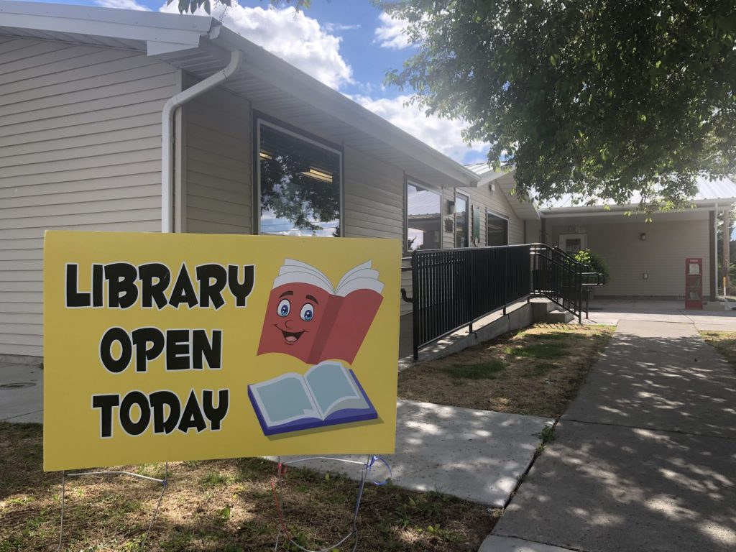
WELCOME TO THE

HANSEN COMMUNITY
LIBRARY

----------HOURS----------

Monday 1:00 - 6:00 p.m.
Wednesday 1:00 - 6:00 p.m.
Friday 1:00 - 6:00 p.m.
Saturday 10 a.m. to 1 p.m.

Hansen Free Library District
120 West Maple Avenue
P. O. Box 150
Hansen, ID 83334-0150
hansenfld@gmail.com http://hansen.lili.org
208-423-4122
Services

Registration: Library service is available to all residents of the Library District or Hansen School District without enrollment fee, as the library is supported by district property taxes. To register, please fill out a family application form; the information is kept on file at the library, a number is issued for the family, and a card given out. Children under 16 should be accompanied by an adult to register.

Library service for non-residents of the district is available upon payment of a $15 annual fee.

Materials Collection: The Library has a collection of books encompassing the interests of all ages. The juvenile collection ranges from board books for the toddler to both fiction and non-fiction for the grade school child and young adult. The adult collection includes both fiction, including best sellers, popular fiction and classics, and non-fiction titles, which includes basic information sources. We also offer a selection of large print books and an Idaho collection.

We have current and back issues (up to a year old) of many magazines, as well as microfilm and CD’s of the Kimberly Advertiser and East County Chronicle newspapers from 1935.

Audio-Visual Material: A collection of recorded books on compact discs is also available. We offer videos for check-out, which includes children’s, education, popular and classics.

Public Access Computers are available for your convenience; a signed Internet Use Policy is required by each user, including children under 18, whose policy is also signed by a parent or guardian. Children under eight years of age must have an adult with them when using the Internet. The computer lab is limited to adult only use from 1 to 3 p.m. Monday, Wednesday and Friday; all ages are welcome to use the computers after 3 p.m. and from 10 a.m. to 1 p.m. on Saturdays.

Services: The staff is pleased to help patrons with reference questions and to recommend titles. If an item from our library’s collection is not immediately available, it may be put “on reserve,” and the patron will be notified when the item is available. It will be held for three library days. If not picked by the end of the third day, it will be put on the shelf for general circulation. Interlibrary loan service is offered for informational needs or items not available at our library.

A copy machine is available for public use; black-and-white copies are 10¢, and color copies are 25¢ each, including computer copies. Students are allowed copies for school reports free of charge. Also available are Applications for Talking Books through the Idaho Commission for Libraries.

RULES AND REGULATIONS

Checkout procedure: Most items, including books, magazines and audio materials, are checked out for a 14-day period. Materials may be renewed up to three times, except for new books, which may be renewed only once. Videos are checked out for one week, and may be renewed if brought into the library and if there are no holds on it; you must be 12 years or older to check out videos.

Overdue fines: It has been determined that the imposition of fines does not act as an effective deterrent to the late return of materials, but fines do serve as an inequitable barrier to service, disproportionately impacting children and community members who have the least financial resources. Given the Library’s core values of equitable service and barrier-free access to information and services, we do not impose or collect fines for the late return of materials. Materials lost by a patron shall be charged the price of the material shown in the database, with a possible processing fee added.

